Ex.No:17 PERFORMANCE EVALUATION OF DIGITAL COMMUNICATIONSYSTEMS USING EYE DIAGRAM ANALYSIS UNDER ADDITIVE WHITE GAUSSIAN NOISE (AWGN) USING MATLAB
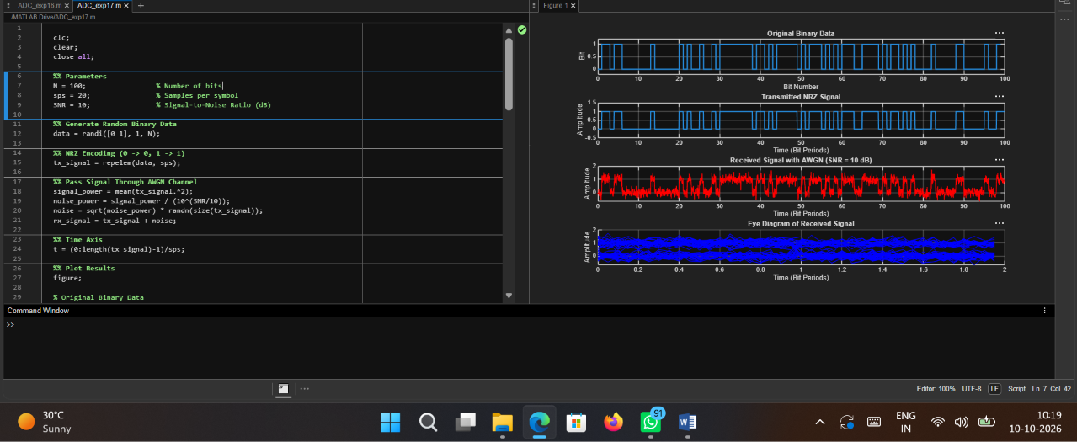
Objective 1:

Code:
clc; clear; close all;

%% Parameters
N = 100; % Number of bits
sps = 20; % Samples per symbol
SNR = 10; % Signal-to-Noise Ratio (dB)

%% Generate Random Binary Data data = randi([0 1], 1, N);

%% NRZ Encoding (0 -> 0, 1 -> 1)
tx_signal = repelem(data, sps);

%% Pass Signal Through AWGN Channel signal_power = mean(tx_signal.^2); noise_power = signal_power / (10^(SNR/10));
noise = sqrt(noise_power) * randn(size(tx_signal)); rx_signal = tx_signal + noise;

%% Time Axis
t = (0:length(tx_signal)-1)/sps;

%% Plot Results figure;

% Original Binary Data subplot(4,1,1);
stairs(0:N-1, data, 'LineWidth', 1.5); grid on;
title('Original Binary Data'); xlabel('Bit Number'); ylabel('Bit');
ylim([-0.2 1.2]);

% Transmitted NRZ Signal subplot(4,1,2);
plot(t, tx_signal, 'LineWidth', 1.5); grid on;
title('Transmitted NRZ Signal'); xlabel('Time (Bit Periods)'); ylabel('Amplitude');
ylim([-0.5 1.5]);

% Received Signal After AWGN subplot(4,1,3);
plot(t, rx_signal, 'r'); grid on;
title(['Received Signal with AWGN (SNR = ', num2str(SNR), ' dB)']); xlabel('Time (Bit Periods)');
ylabel('Amplitude');
% Eye Diagram (manual plotting; no eyediagram function required) subplot(4,1,4);
hold on;

for k = 1:2:(N-2)
idx = (k-1)*sps + 1;
segment = rx_signal(idx:idx+2*sps-1); time_segment = (0:2*sps-1)/sps; plot(time_segment, segment, 'b');
end
grid on;
title('Eye Diagram of Received Signal'); xlabel('Time (Bit Periods)'); ylabel('Amplitude');
xlim([0 2]); hold off;

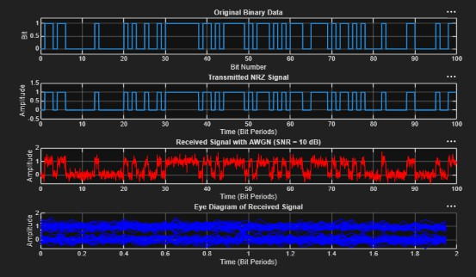
Output:

